**Arduino Projects Documentation**

**NAME : KURAKULA SAMBA SIVA REDDY  
REG NO : RSAGWPVLSI12**

**1. Distance Measurement Display**

**Objective**

Measure the distance to an object using an ultrasonic sensor and display the result on a 7-segment display.

**Components Used**

* Arduino Uno
* Ultrasonic Sensor (HC-SR04)
* 7-Segment Display
* Resistors (for current limiting)

**Description**

This project utilizes an ultrasonic sensor to measure the distance to an object directly in front of it. The distance is displayed in Centi meters on a 7-segment display, providing a visual representation of the measured distance.

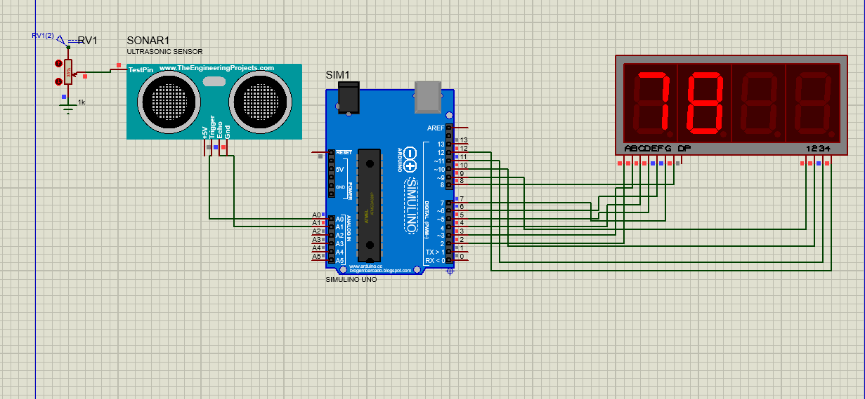

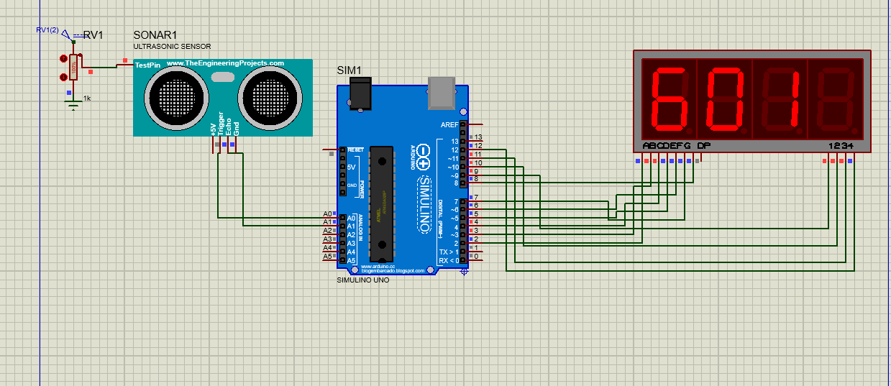

**2. Smart Distance Counter**

**Objective**

Increment a counter displayed on a 7-segment display every time an object crosses a specified distance threshold detected by an ultrasonic sensor. Reset the counter using a touch sensor.

**Components Used**

* Arduino Uno
* Ultrasonic Sensor (HC-SR04)
* Touch Sensor
* 7-Segment Display

**Description**

In this project, the ultrasonic sensor detects when an object approaches within a specific distance, triggering the counter to increment. The touch sensor is employed to reset the counter when necessary.

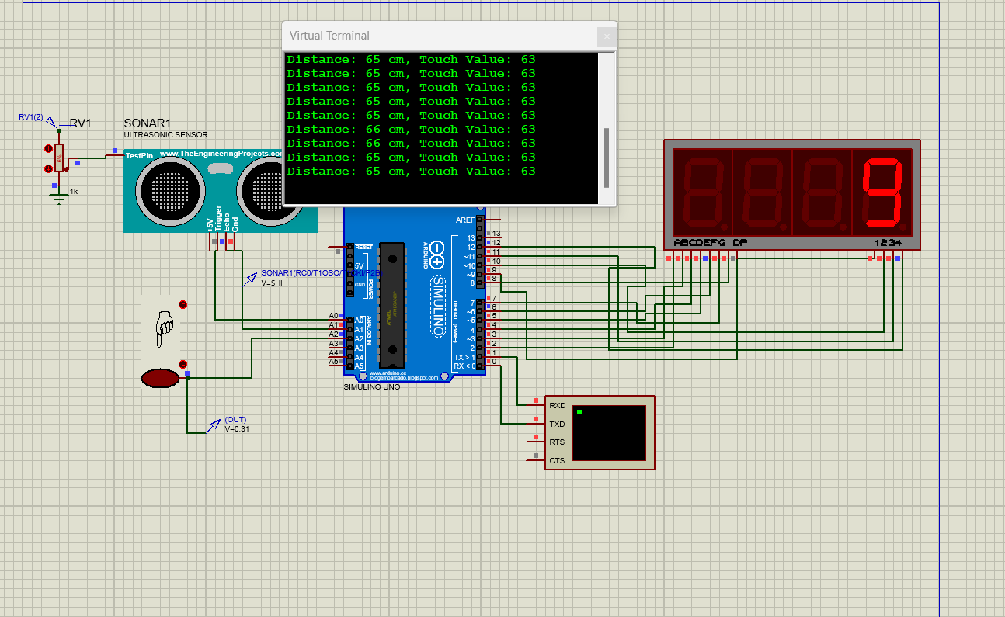

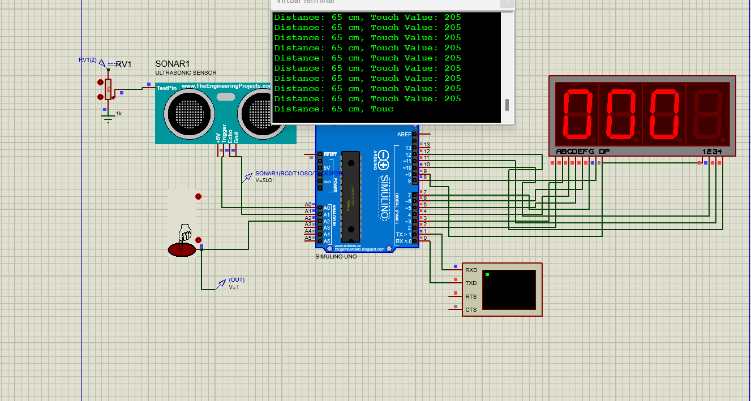

**3. Touch-Activated Range Finder**

**Objective**

Take a distance reading from the ultrasonic sensor only when the touch sensor is activated. Display the measured distance on the 7-segment display for 5 seconds.

**Components Used**

* Arduino Uno
* Ultrasonic Sensor (HC-SR04)
* Touch Sensor
* 7-Segment Display

**Description**

This project waits for the touch sensor to be activated before measuring the distance with the ultrasonic sensor. Once the distance is measured, it is displayed on the 7-segment display for a duration of 5 seconds before clearing the display.

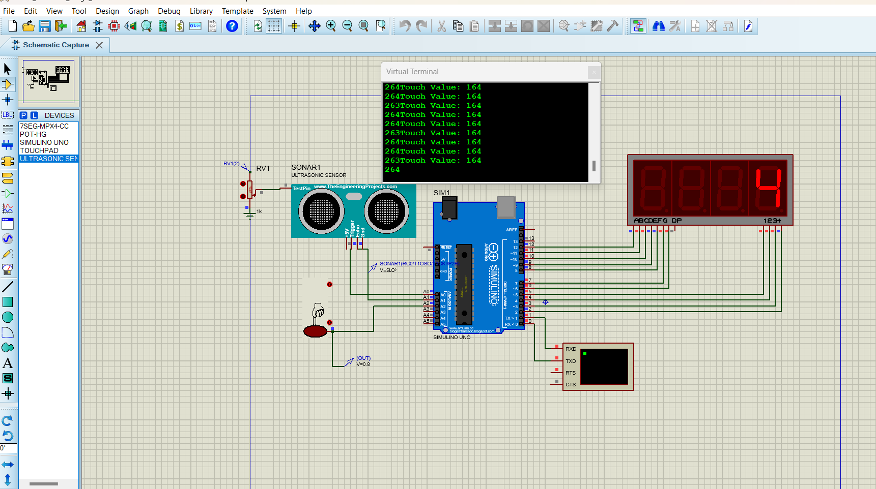

**4. Countdown Timer with Obstacle-Activated Reset**

**Objective**

Use a touch sensor to start a countdown timer, resetting it if an obstacle is detected by the ultrasonic sensor. Display "E" on the 7-segment display upon completion of the countdown.

**Components Used**

* Arduino Uno
* Ultrasonic Sensor (HC-SR04)
* Touch Sensor
* 7-Segment Display

**Description**

In this project, a countdown timer begins when the touch sensor is activated. If an obstacle is detected by the ultrasonic sensor during the countdown, the timer resets. If the countdown completes successfully without interruption, the letter "E" is displayed on the 7-segment display.

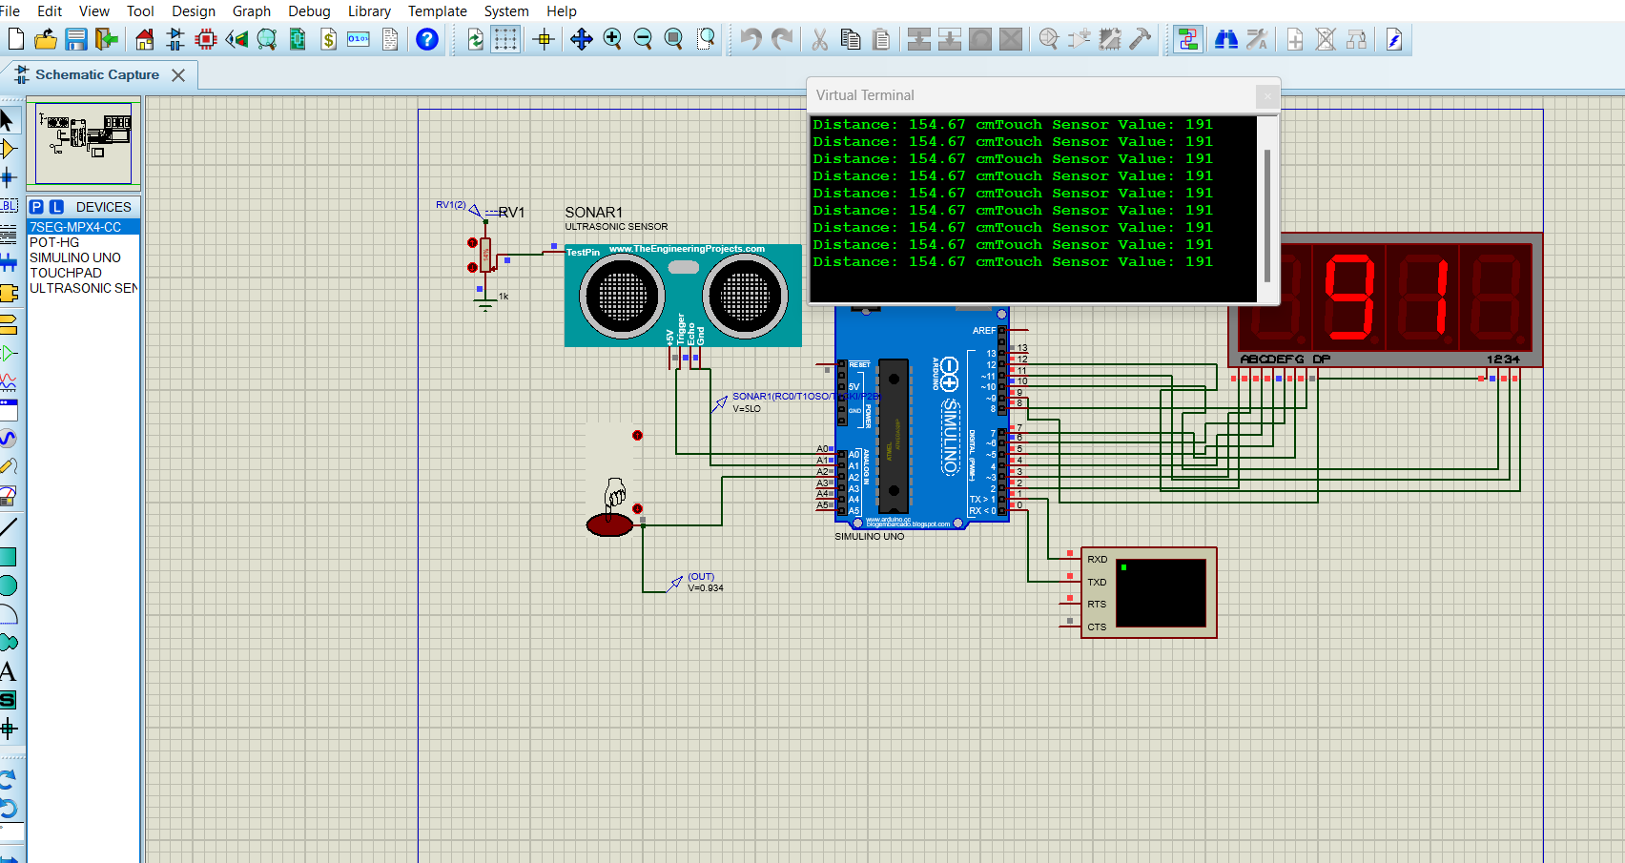

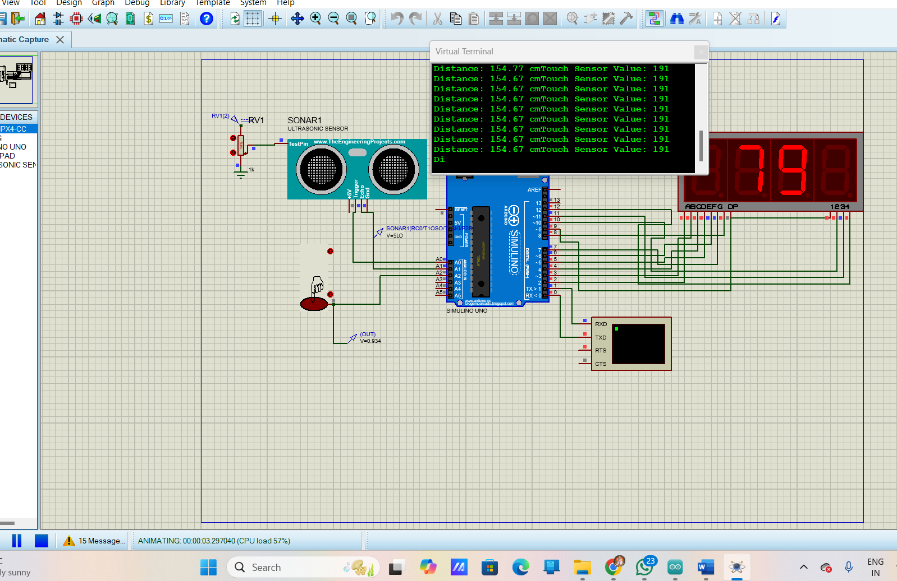

**5. Digital Stopwatch**

**Objective**

Create a stopwatch using an LCD display and two buttons for starting/stopping and resetting the timer.

**Components Used**

* Arduino Uno
* LCD Display (16x2)
* Push Buttons

**Description**

This project features a simple stopwatch design where one button starts or stops the timing, while another button resets the timer. The elapsed time is displayed on an LCD display.

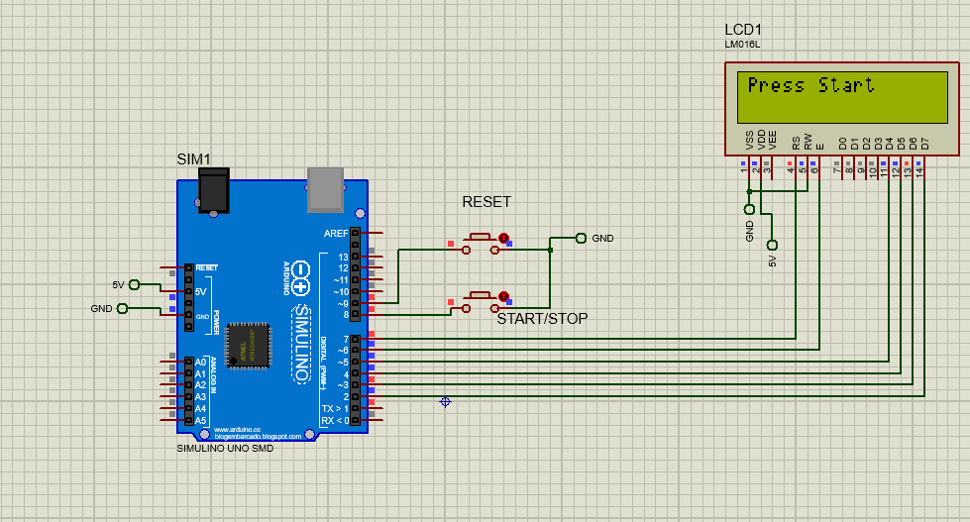

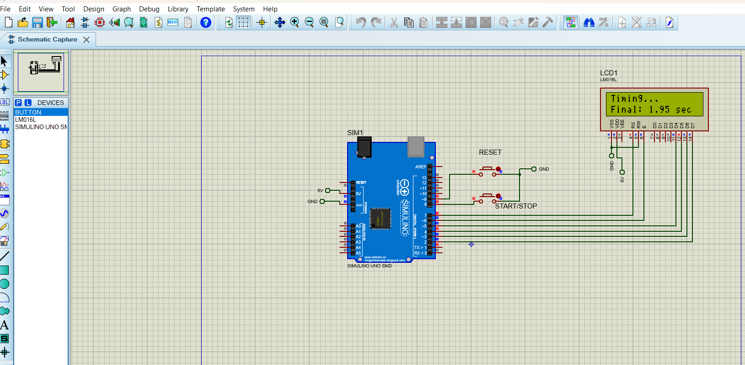

**6. Motion-Activated Alarm**

**Objective**

Detect movement using a PIR sensor and sound a buzzer when motion is detected. Log timestamps of each detected movement in the Serial Monitor.

**Components Used**

* Arduino Uno
* PIR Motion Sensor
* Buzzer

**Description**

In this project, a PIR motion sensor is used to detect movement. When movement is detected, a buzzer sounds, and the time of detection is logged in the Serial Monitor for further reference.

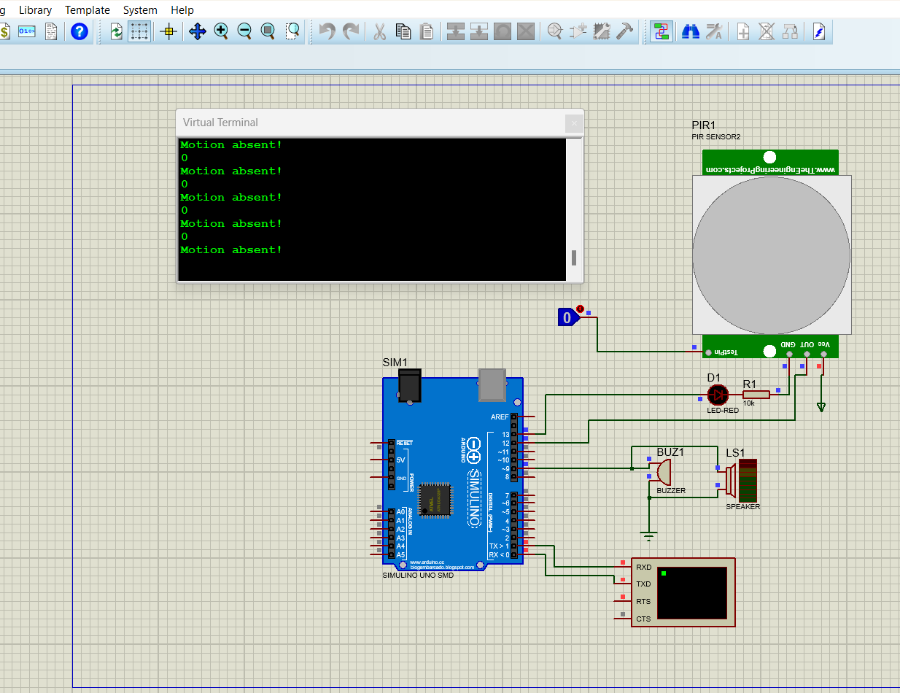

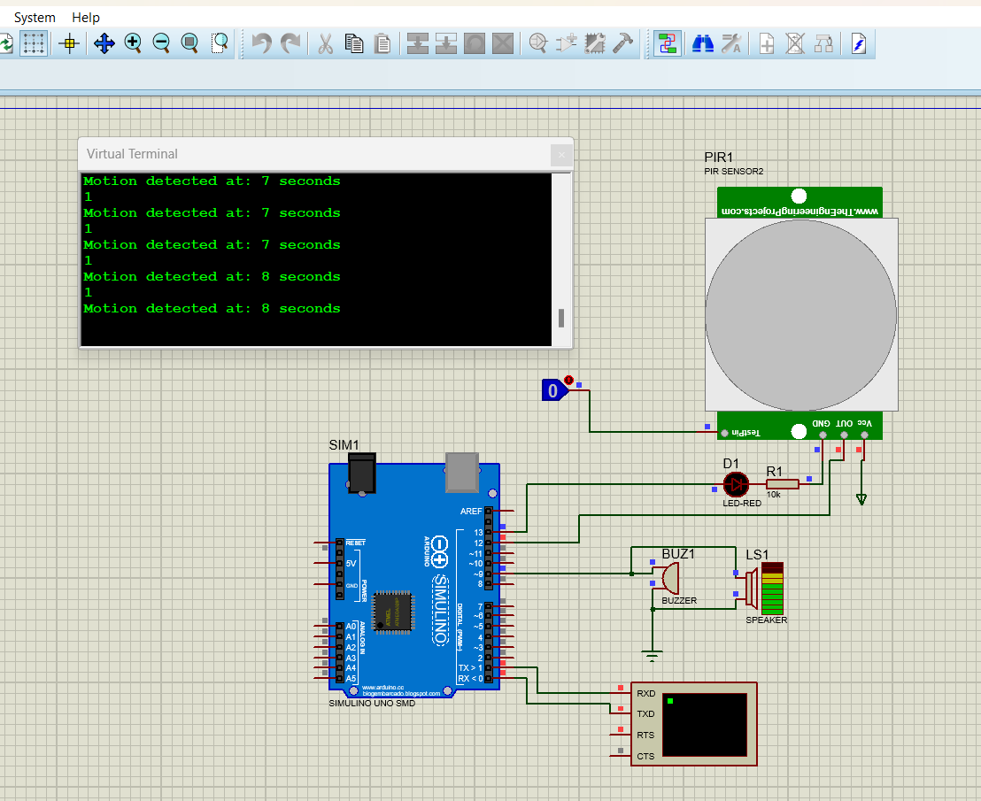

**7. Temperature Monitoring System**

**Objective**

Monitor temperature using a DHT11 or LM35 sensor, displaying the data on the Serial Monitor. Provide a warning if the temperature exceeds a certain threshold.

**Components Used**

* Arduino Uno
* DHT11 Temperature Sensor (or LM35)
* Serial Monitor

**Description**

This project continuously monitors temperature readings from the sensor and displays the data on the Serial Monitor. If the temperature exceeds a predefined limit, a warning message is issued.

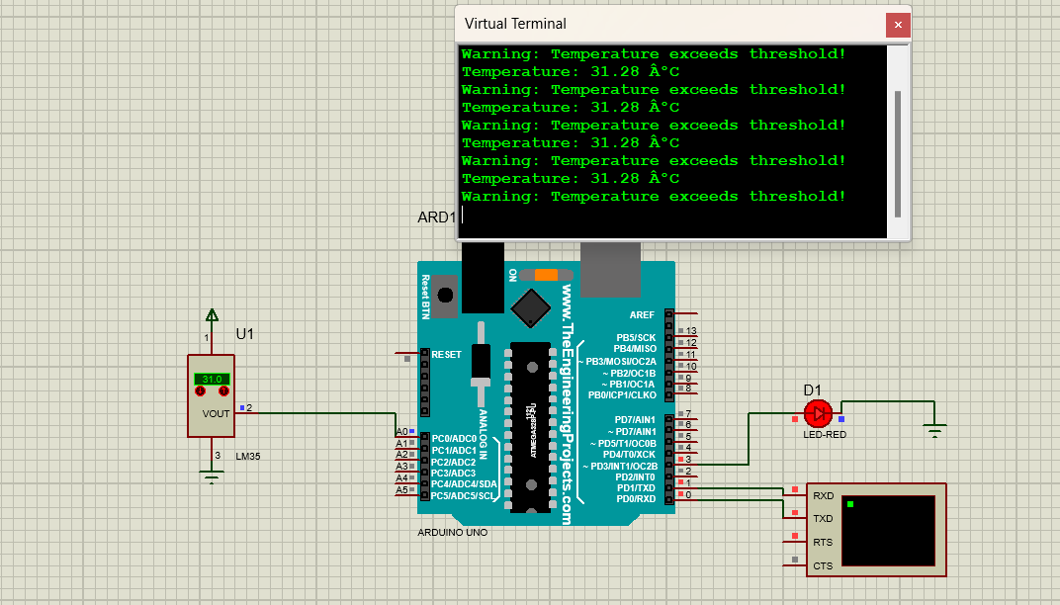

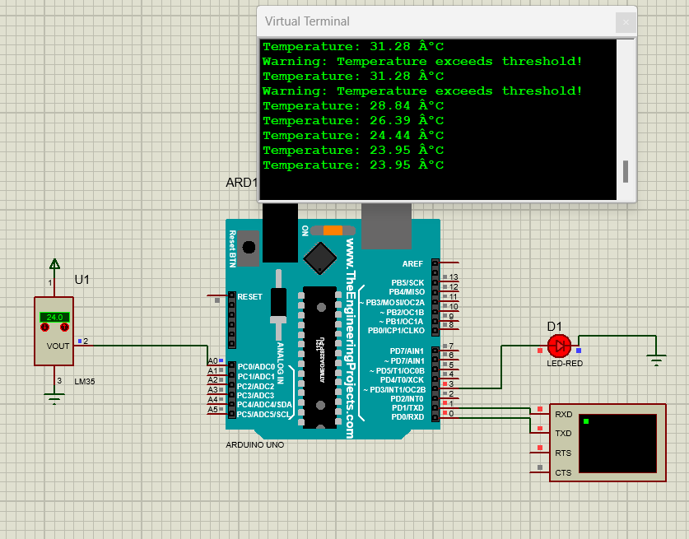

**8. People Counter with Direction Detection**

**Objective**

Count the number of people entering and exiting through a doorway using IR sensors, with direction confirmation from an ultrasonic sensor.

**Components Used**

* Arduino Uno
* IR Sensors (for counting)
* Ultrasonic Sensor (for direction confirmation)
* 7-Segment Display

**Description**

This project employs IR sensors placed on either side of a doorway to count people entering and exiting. The ultrasonic sensor confirms the direction of movement by measuring the time it takes for an object to pass between the two sensors, providing accurate counting.

